Lab 6: Network Monitoring with SDN

Name: Chi Zhang NetID: cz1195 Stu NO.: N10840703

**REPORT:**

1. What is the slice and flowspace? Illustrate using the given topology.

A: Each slice is a controller that manages the part of the network resources. And flowspace means a set of traffics with some specific attributes or type. In our experiment, the slice is each Traffic Monitor Application, and flowspace is the packets running in the topology with different port no..

1. Include the controller’s code.

A: Refer to the attachment.

1. Traffic generators in the VMs repeats a traffic pattern every 2 hours.
   1. Draw a link utilization graph (link utilization vs. time) for link – 1, 2 and 3.

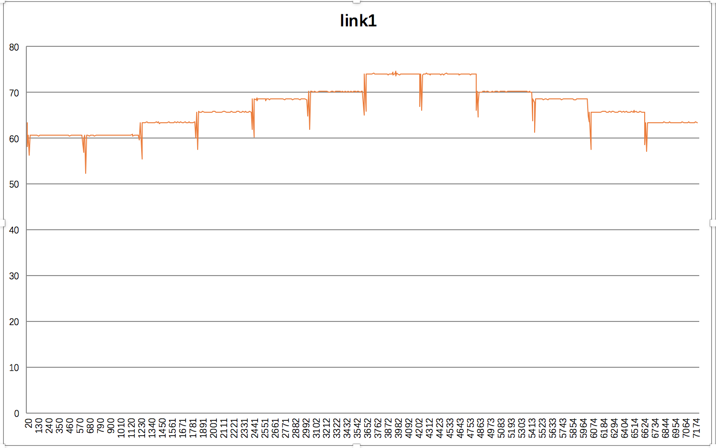

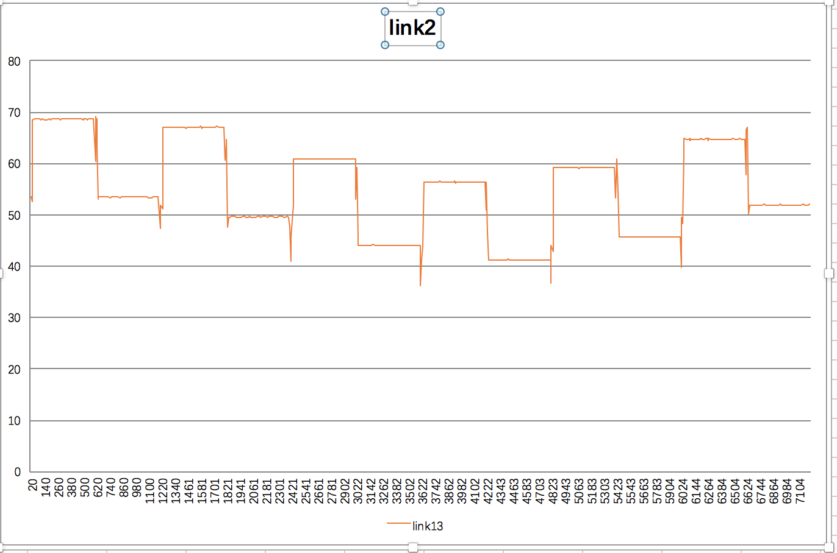

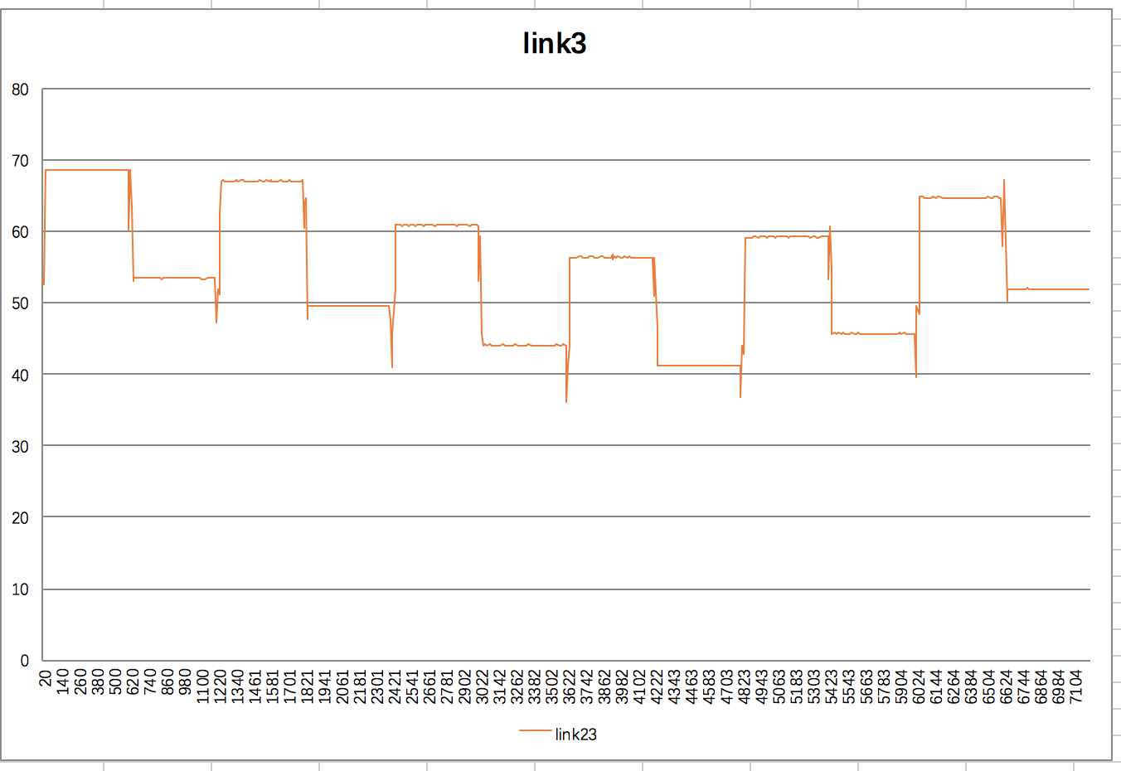

* 1. Find over-utilized links.

The average utilization of three links are 67.01%, 55.18% and 55.18% respectively. The link 1 owns the highest avg utilization, but none of this three links is over-utilized.

1. Screenshots:
   1. Monitoring application successfully running at allocated IP address and Port # on Host 1.

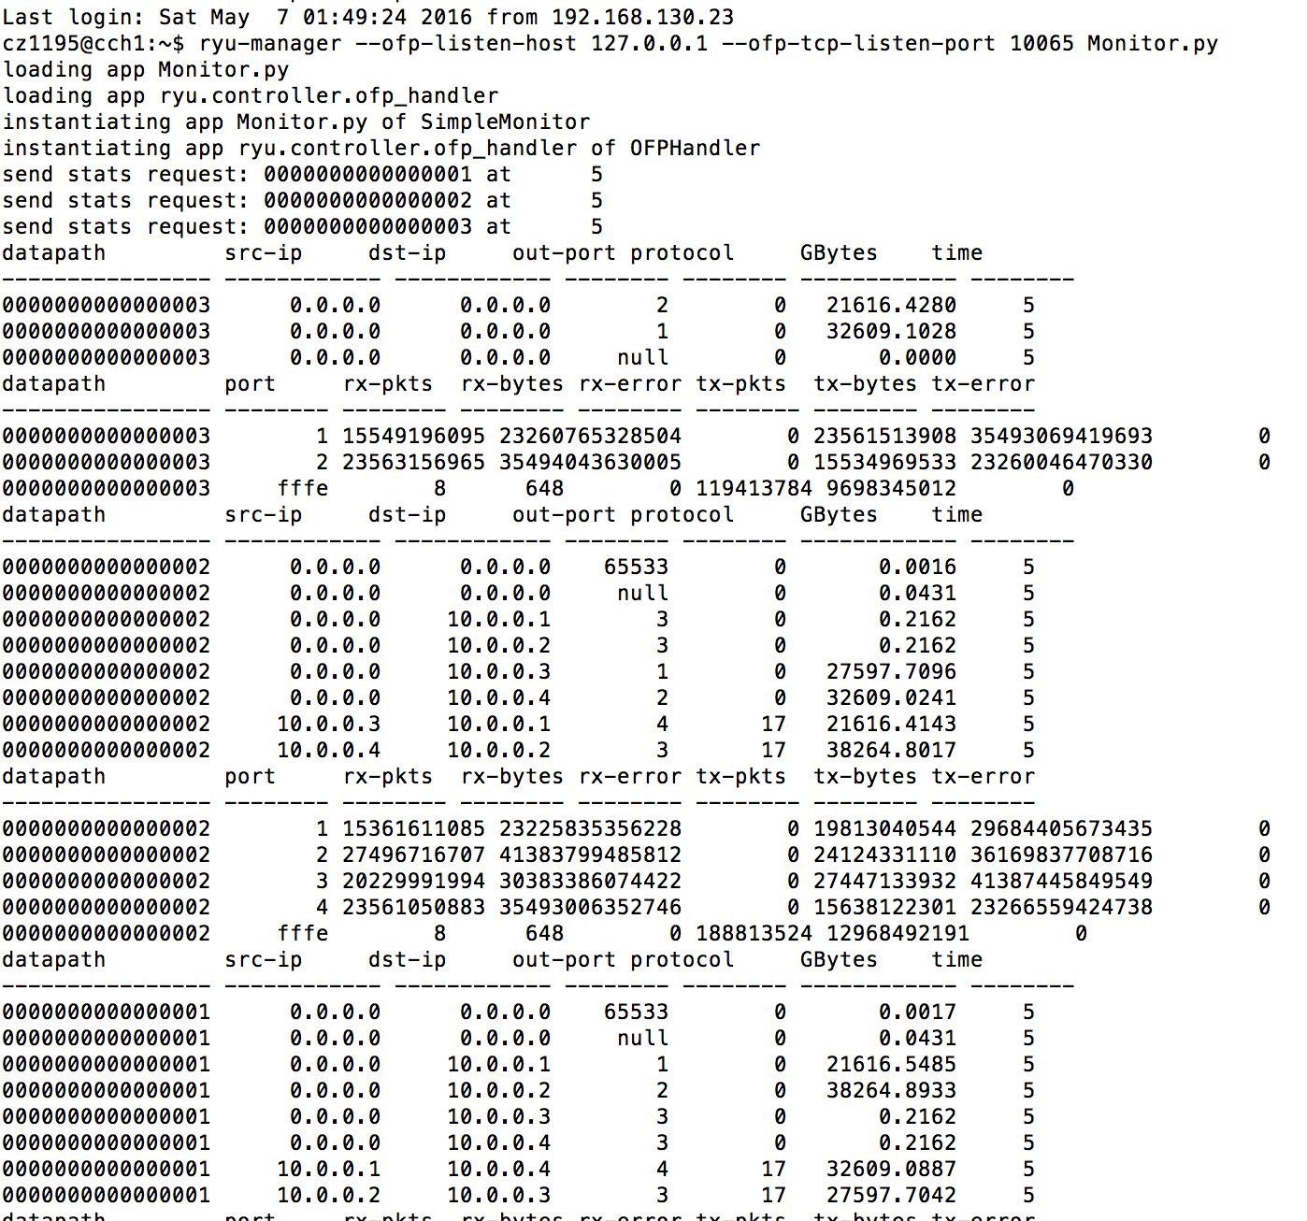

* 1. Screenshot of any 2 consecutive Link utilization for all links.







* 1. Highest traffic generator flow at any instance of time. (Optional)

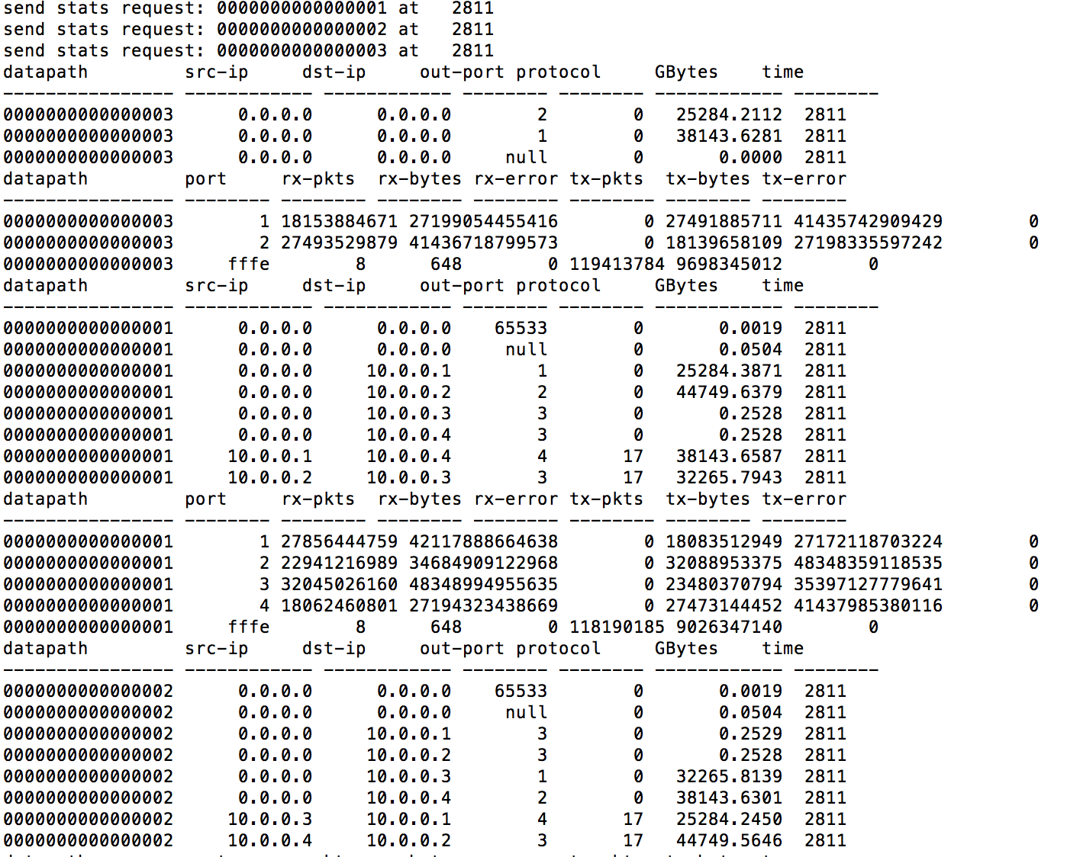

A: We can say that during the instance of time 2811, the highest traffic generator flow is from the vm4, which is circled on the above screenshot.

1. Challenges you’ve encountered while doing this experiment, and explain how you manage to solve them. If you do not experience any problem, simply say no problems.

A: No problems